Placing a Hold on a Book (Elementary)
- After logging into Destiny Discover either search the catalog for a specific title or use the ribbons (recently added, topics so forth) to find a book.
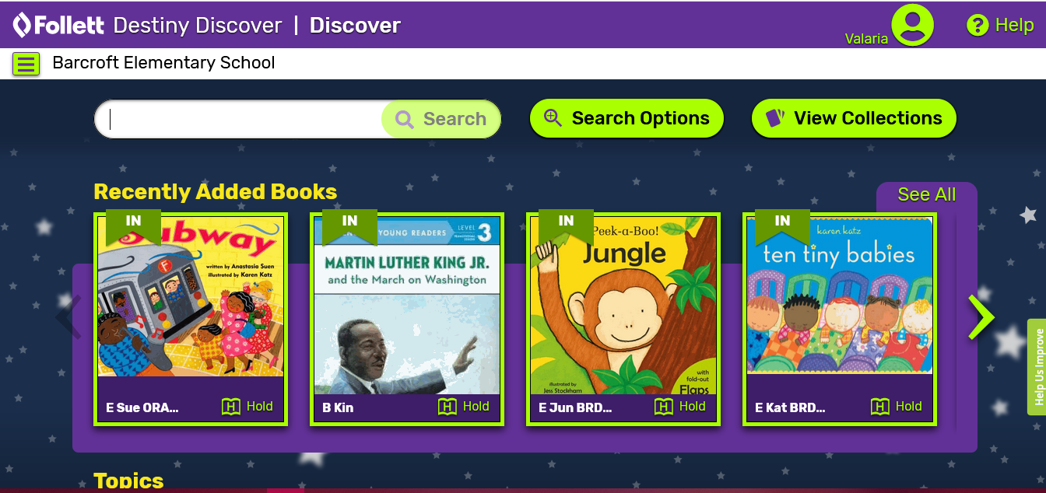
Ribbons. Scroll for more
Type here to search
Use this for a more advanced search.
Patron account. Can see checkouts, holds, fines, so forth

- When you have found a title that you would like simply click the “hold” button. 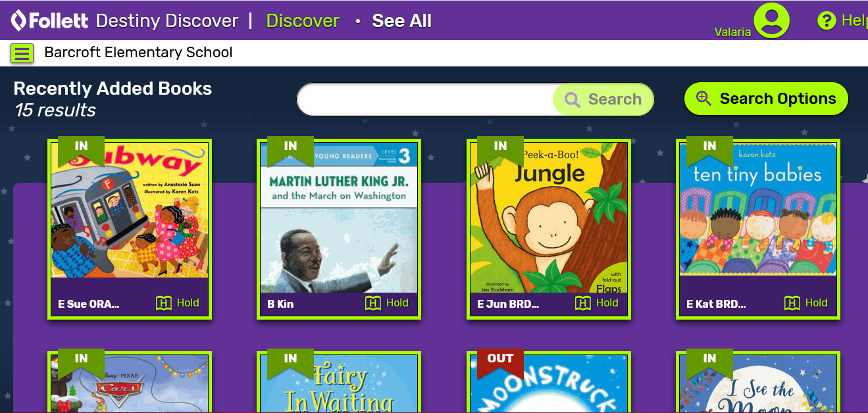
Click here
Status of book

- A message will then appear letting you know you’ve placed the hold. You may also receive a message saying that the title is ready to pick up.
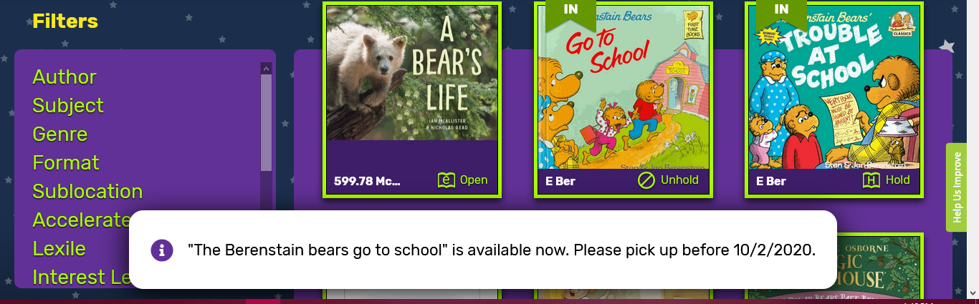
Message letting you know about your hold.

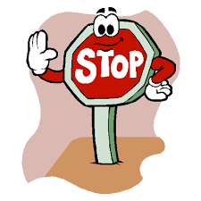

WAIT! Don’t rush to your school just yet!

- You need to wait for you school’s librarian to check-out the hold out to your account. To check your account, click on the person icon and then choose “checkouts”.
View checkouts
Click here

- Once your hold has been checked out it will appear on this page. 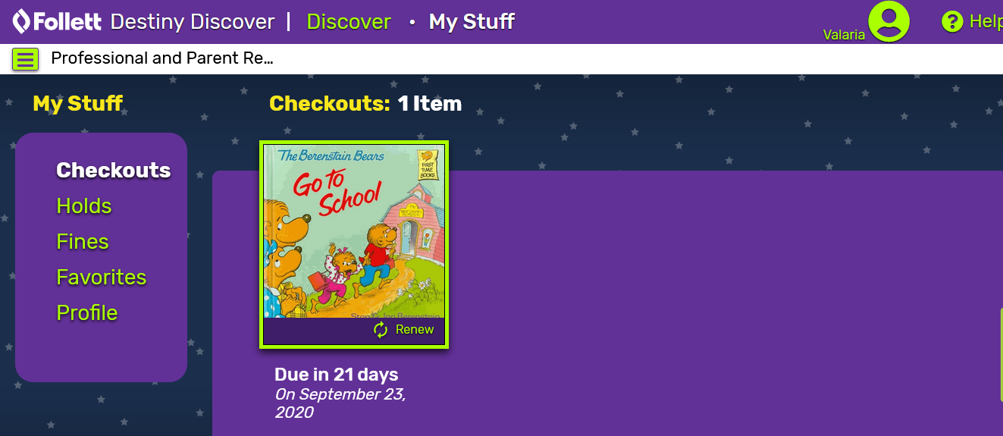
Due date
Your book
The book will move from “holds” to checkouts”

You may now go to your library on Thursdays (9:30am-6pm) to get your books! Happy Reading!

